**CHATBOT FOR MEDICAL HEALTH**

**Project submitted to the**

**SRM University – AP, Andhra Pradesh**

**for the partial fulfillment of the requirements to award the degree of**

**Bachelor of Technology**

**In**

**Computer Science and Engineering**

**School of Engineering and Sciences**

**Submitted by**

**M.Sree annapurna AP21110010791**

**B.Jyothirmai AP21110010794**

**G.Madhurya AP21110010798**

**M.Nandita AP21110010829**

**Under the Guidance of**

**Dr. Randhir Kumar**

**SRM University–AP**

**Neerukonda, Mangalagiri, Guntur**

**Andhra Pradesh – 522 240**



**May, 2024**

# **Certificate**

**Date: 13-May-24**

This is to certify that the work present in this Project entitled “Chatbot for medical health” has been carried out by M.Sreeannapurna, B.Jyothirmai, G.Madhurya, M.Nandita under my/our supervision. The work is genuine, original, and suitable for submission to the SRM University – AP for the award of Bachelor of Technology/Master of Technology in School of Engineering and Sciences.

**Supervisor**

**Dr. Randhir Kumar**

**Assistant Professor, Dept. of CSE**

**SRM University AP.**

# 

# 

# 

# 

# 

# 

# 

# **Table of Contents**

**Certificate.......................................................................................................................2**

**Table of Contents..........................................................................................................3**

**Abstract.........................................................................................................................4**

**Introduction..................................................................................................................5**

**Features of the project:........................................................................................6**

**Problem Statement (Use Case) Analysis..........................................................7**

**Identified Use Cases....................................................................................... 7**

**Identified Actors..............................................................................................8**

**Use Case Diagram...........................................................................................9**

**Software And Hardware Requirements.......................................................................12**

**Data Flow Diagram..........................................................................................12**

**Sequence Diagram..........................................................................................14**

**Results/Performance Evaluation............................................................................15**

**Limitations, Future Scope & Conclusion................................................................17**

**References ……………………………………................................................................19**

**Abstract:**

Artificial intelligence is used by a Chatbot for medical assistance to carry out a number of functions, including appointment scheduling, reminders for medications, and general health information provision. Chabot’s relieve the strain on healthcare systems by taking on these duties, freeing up medical personnel to concentrate more on intricate care duties. AI Chabot’s can help with routine tasks like making appointments, remembering when to take prescriptions, checking symptoms, triaging patients, and providing health support. However, in more complex situations, like diagnosing uncommon or difficult-to-treat conditions, carrying out surgical procedures, providing empathetic counseling, interpreting complex diagnostic tests, and creating treatment plans, AI Chabot’s cannot take the place of human medical professionals.

**Introduction:**

Traditional chatbots are rule-based and follow a predefined set of rules and responses programmed by developers. These chatbots can only respond to specific user inputs and cannot adapt to new or unexpected scenarios. They typically rely on simple decision trees or if-then statements to guide the conversation.

Traditional chatbots, in contrast to conversational AI, are less flexible and more prone to mistakes because they are not able to process natural language or comprehend context. Text-based, they provide text-based answers to user input and queries. Their interactions are restricted to text because they are unable to comprehend or react to spoken language.

**Drawbacks of traditional methods:**

Limited Interactions: For consumers who prefer more conversational and natural interactions, the fact that traditional chatbots are usually restricted to text-based interactions can be annoying.

Limited Personalization: Personalized experiences may be negatively impacted by traditional chatbots' generic responses, which frequently ignore the particular circumstances or preferences of each user.

Limited flexibility - They struggle to understand user inputs outside their programmed parameters, leading to a negative user experience.

Natural language processing, or NLP, is a tool used by AI chatbots to understand and interpret human language in a meaningful and context-sensitive way. They examine enormous volumes of data, spot trends, and hone their responses in response to user interactions by using machine learning.

Enhanced productivity: AI chatbots optimize resources and save time by multitasking, managing numerous requests, and automating repetitive tasks.  
Personalization: By providing customized experiences based on consumer data, they promote brand loyalty.  
 Data analysis: AI chatbots gather consumer data, enabling companies to optimize their approaches and spot business opportunities.

**Problem analysis and project planning:**

**Features we have in our project:**

24/7 Availability: Medical chatbots are available around the clock, providing patients with instant access to medical assistance whenever they need it.

Fast Response Time: With AI technology, medical chatbots can answer questions much faster than a human

Personalized Care: Medical chatbots provide patients with a non-judgmental and private way to share medical information, allowing them to feel more comfortable discussing sensitive topics.

**Objectives:**

The purpose of the document is to define the requirements of the chatbot for medical support. This supplementary specification lists the requirements that are not readily captured in the use cases of the use case model. The Supplementary specification & the use case model together capture a complete set of requirements on the system.

**Scope**:

This supplementary specification applies to the health chat bot system. This specification defines the non-functional requirements of the System, such as reliability, usability, performance and supportability as well as functional requirements that are common across a number of use cases.

**Problem statement:**

Lack of access to healthcare information services, particularly in places with limited or unreachable resources, is the issue that our chatbot is intended to solve. People may find it difficult to receive the care they require due to obstacles like lengthy wait times, language barriers, and a lack of resources. By offering patients trustworthy medical advice and care without requiring them to physically visit healthcare facilities, our chatbot seeks to address these problems. Patients will find it easier to swiftly and conveniently receive the care they require when they use the Chabot’s ability to identify symptoms, diagnose medical conditions, and offer pertinent medical advice. Furthermore, by lessening their workload, chatbots can free up healthcare professionals to concentrate on more complicated cases.

**Problem statement (Use case) analysis:**

**Medical chatbot uses :**

**Symptom assessment:**

The chatbot can ask a series of questions to assess a patient's symptoms and provide preliminary advice on whether self-care, a visit to a healthcare facility, or further consultation with a medical professional is needed.

**Medication management:**

The chatbot can remind patients to take their medication, provide information on proper dosage and usage, and help manage refills.

**Health education:**

The chatbot can share information on various health topics, offer tips for maintaining a healthy lifestyle, and provide reminders for routine check-ups and screenings.

**Data collection and analysis:**

The chatbot can collect valuable data on patient interactions, helping healthcare providers identify trends, monitor patient outcomes, and improve service delivery

**Identified actors:**

**Patients:**

These are the individuals who interact with the chatbot to seek medical advice, get symptom assessments, and receive health-related information.

**Healthcare Providers:**

These are medical professionals who validate the Chatbot’s diagnoses and provide further medical attention to patients. They can include doctors, nurses, and other healthcare specialists.

**Healthcare Organizations:**

These are the entities that implement the medical chatbot within their healthcare system. They can include hospitals, clinics, and other healthcare providers.

**Data Analysts:**

These are the individuals who analyze the Chatbot’s data to improve its performance, enhance accuracy, and provide more personalized recommendations.

**Patients' Family Members:**These are the individuals who may also interact with the chatbot on behalf of the patient, seeking medical advice or providing patient information.

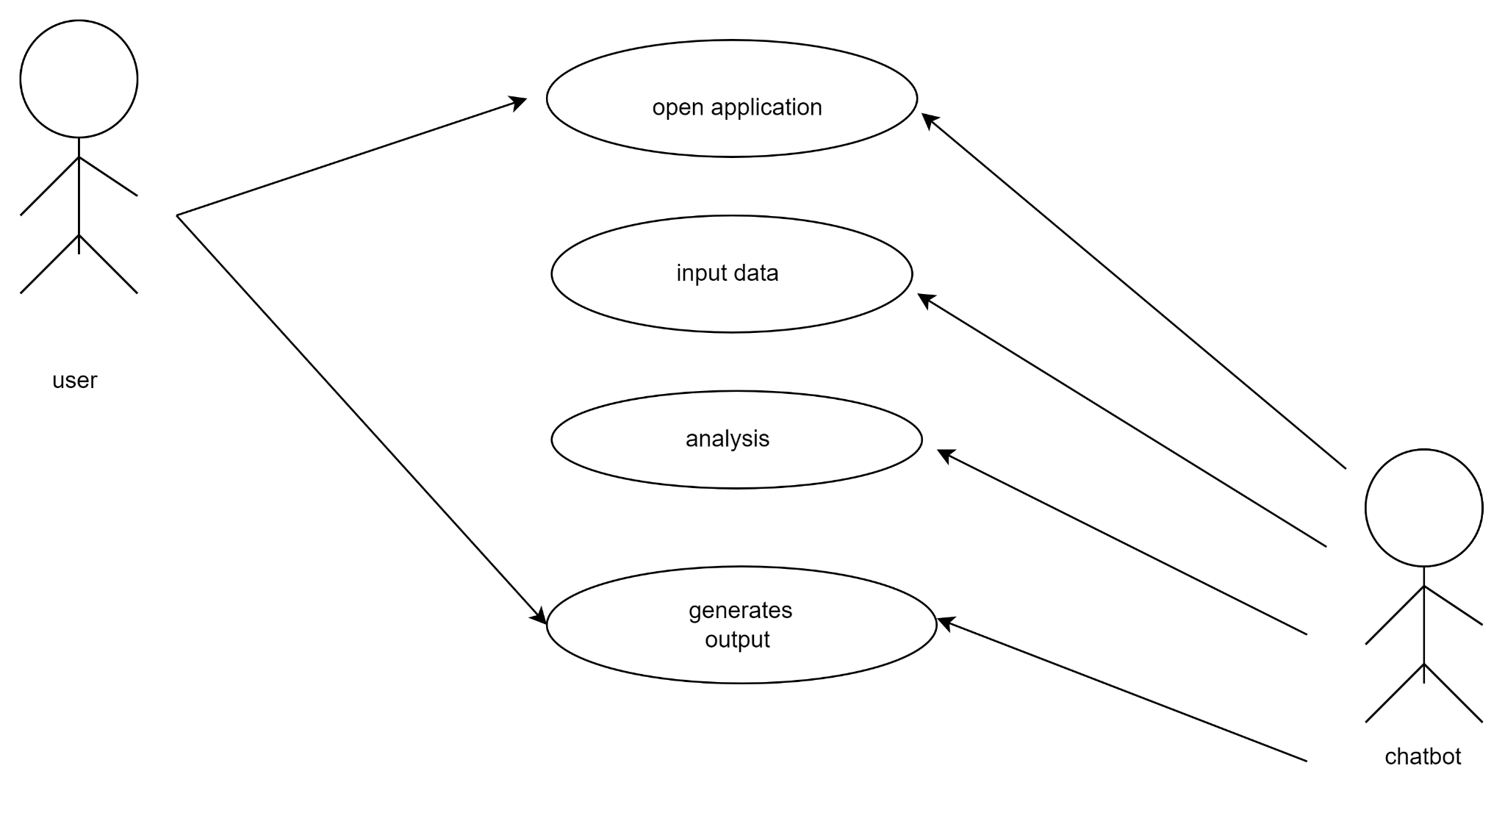

**Design of medical support chatbot**

**Basic Flow:**

**User Accesses Homepage (/)**

The user accesses the homepage where they are presented with an option to input symptoms.

They can choose to proceed to the prediction page or navigate to other pages like About or Blog.

**User Inputs Symptoms and Submits Form (/predict)**

The user enters their symptoms separated by commas in a form field and submits the form.

The form data is sent to the server using a POST request.

**Symptoms Prediction and Result Display**

The server receives the symptoms data, processes it using the prediction model, and predicts the possible disease.

It then fetches relevant information such as disease description, precautions, medications, recommended diet, and workout routines.

The server renders the prediction result along with fetched information on the same page (index.html).

User Navigation

The user can navigate to other sections like About or Blog using the navigation links provided.

**Alternative Flow:**

Empty or Incorrect Symptoms Input

If the user submits an empty form or enters incorrect/misspelled symptoms, they receive a message prompting them to enter valid symptoms.

They are redirected back to the homepage with the message displayed.

**Pre-Conditions:**

**Dataset and Model Availability**

Ensure that the CSV datasets (symptoms_df.csv, precautions_df.csv, workout_df.csv, description.csv, medications.csv, diets.csv) are available in the specified file paths.

The trained model (svc.pkl) for disease prediction is available and loaded successfully using pickle**.**

**Post-Conditions:**

**Application Execution**

The Flask application runs successfully without errors.

Users can access the homepage, enter symptoms, receive predictions, and view relevant information without encountering issues.

Navigation to other sections like About or Blog works as expected.

This design covers the basic functionalities, potential alternative scenarios, and pre/post-conditions to ensure smooth execution of your Flask application for disease prediction.ort system

**Nonfunctional requirements**

**4. Software Quality Attributes**

**• AVAILABILITY:** Since the project will be hosted on the server it will be available all the time.

**• CORRECTNESS:** The system should generate an appropriate report

**• MAINTAINABILITY:** The system should maintain correct schedules

**• USABILITY:** The system should satisfy the maximum number of user’s needs.

**5. Software and Hardware Requirements**

5.1. Software Requirements

• PHP (front end)

• HTML

• JavaScript

• MS Word 97 or later

• Web Browser: Microsoft Internet Explorer, Mozilla, Google Chrome or later

• python

• Operating System: Windows XP / Windows7/ Windows Vista

5.2. Hardware Requirements

• Pentium IV or higher, (PIV-300GHz recommended)

• 256 MB RAM

• 1 Gb hard free drive space

Server Required

• Four 2.8 GHz core processors

• 16 GB of RAM

• 10 GB of hard disk space

**Data flow diagrams**

**LEVEL 0:**



**LEVEL1 1**: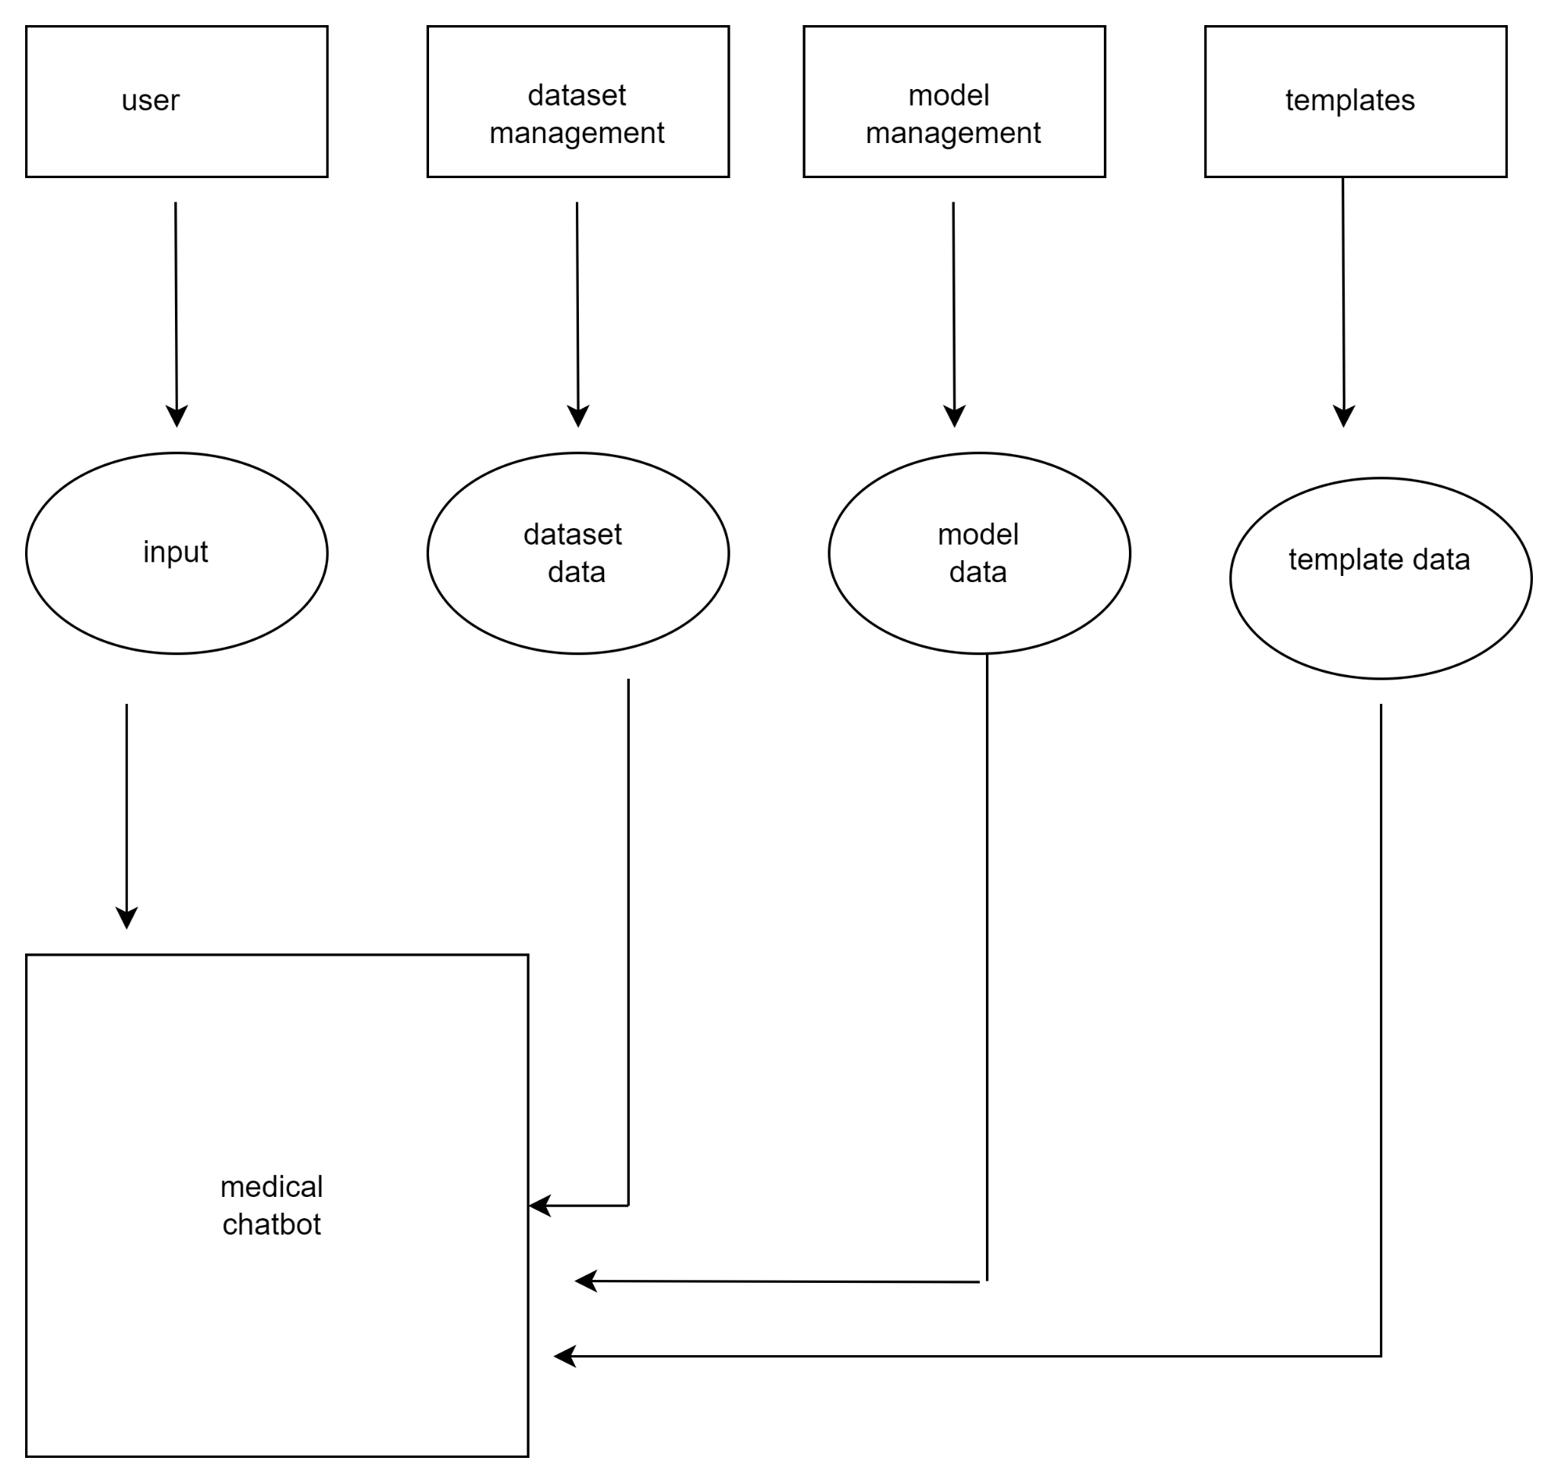

**LEVEL 2:**

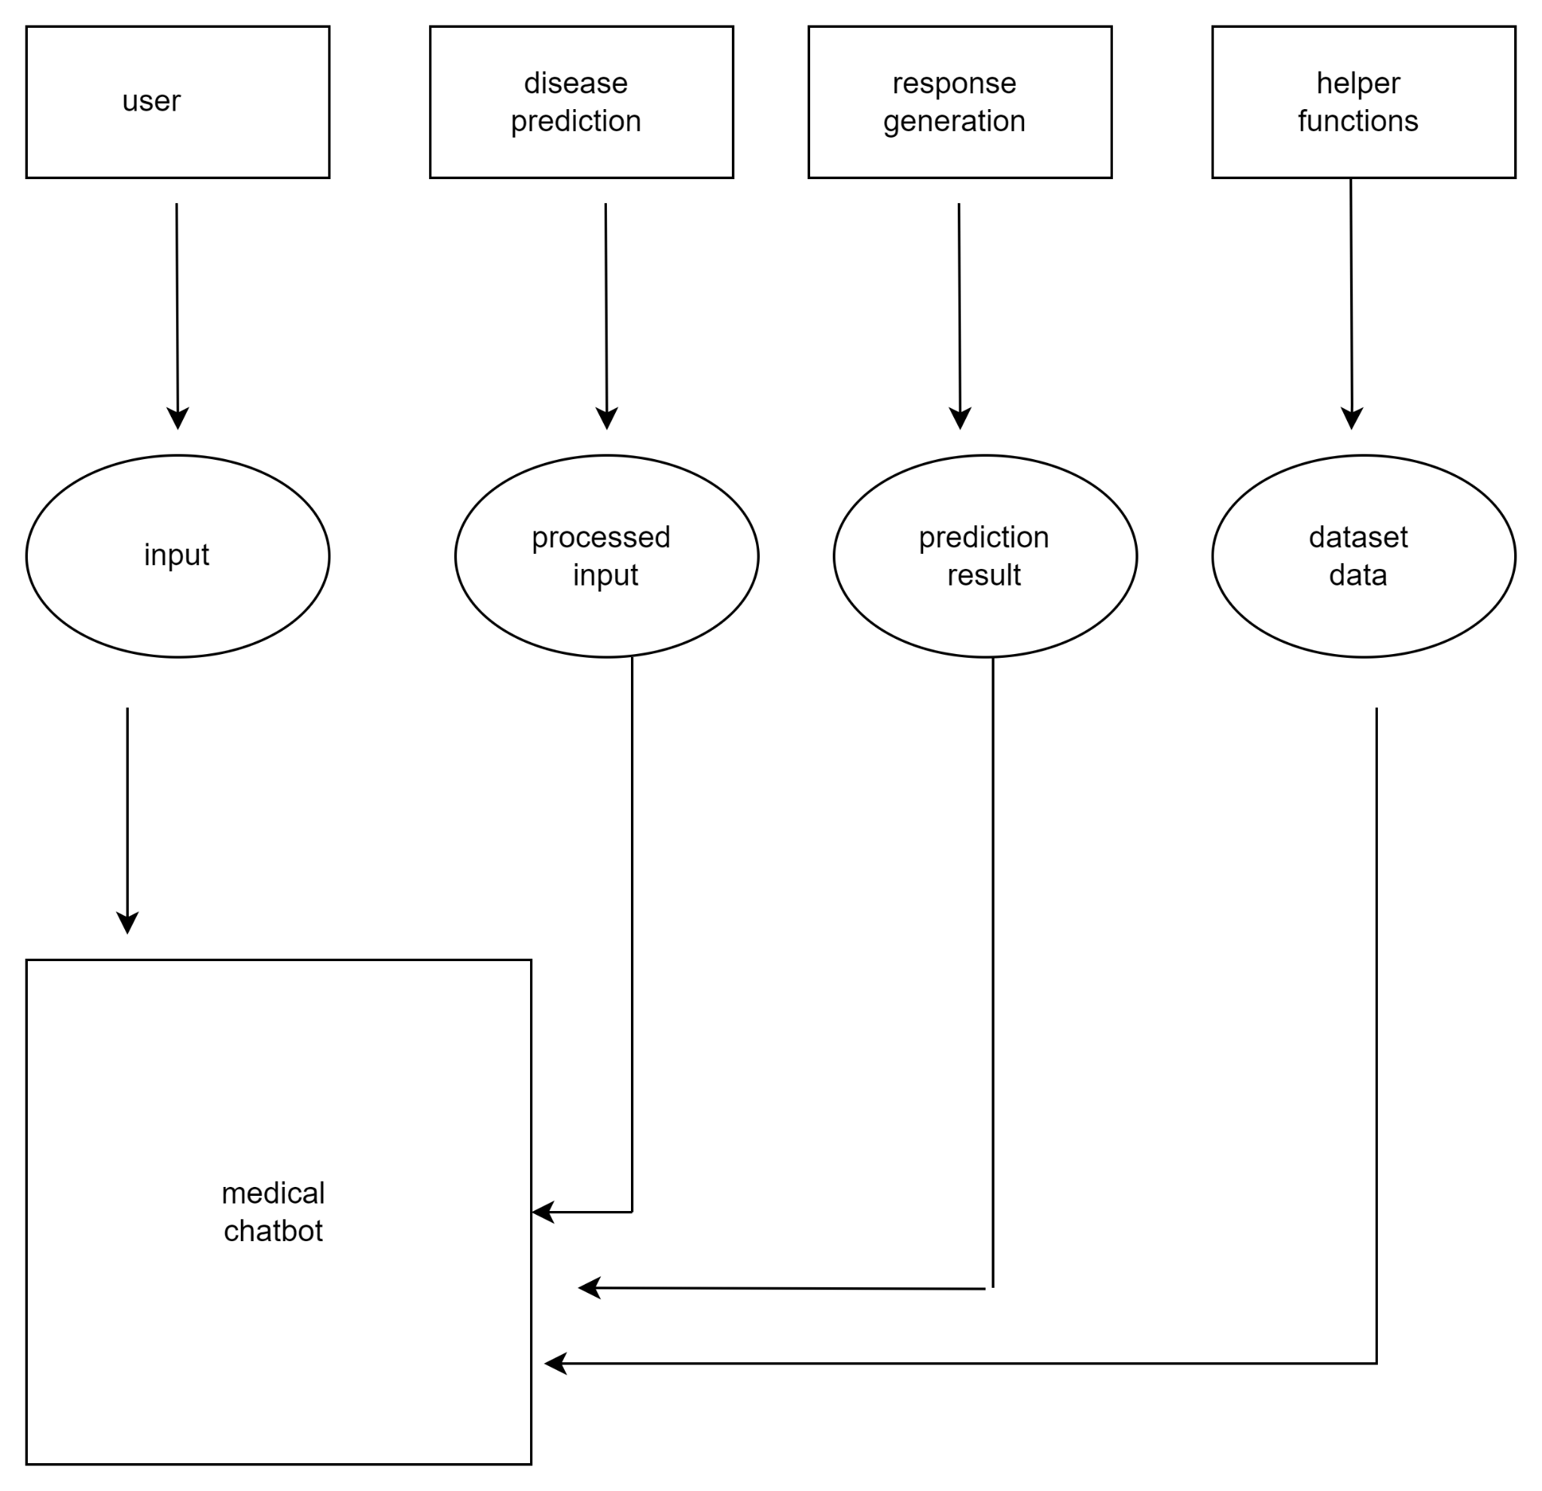

**Sequence diagram**

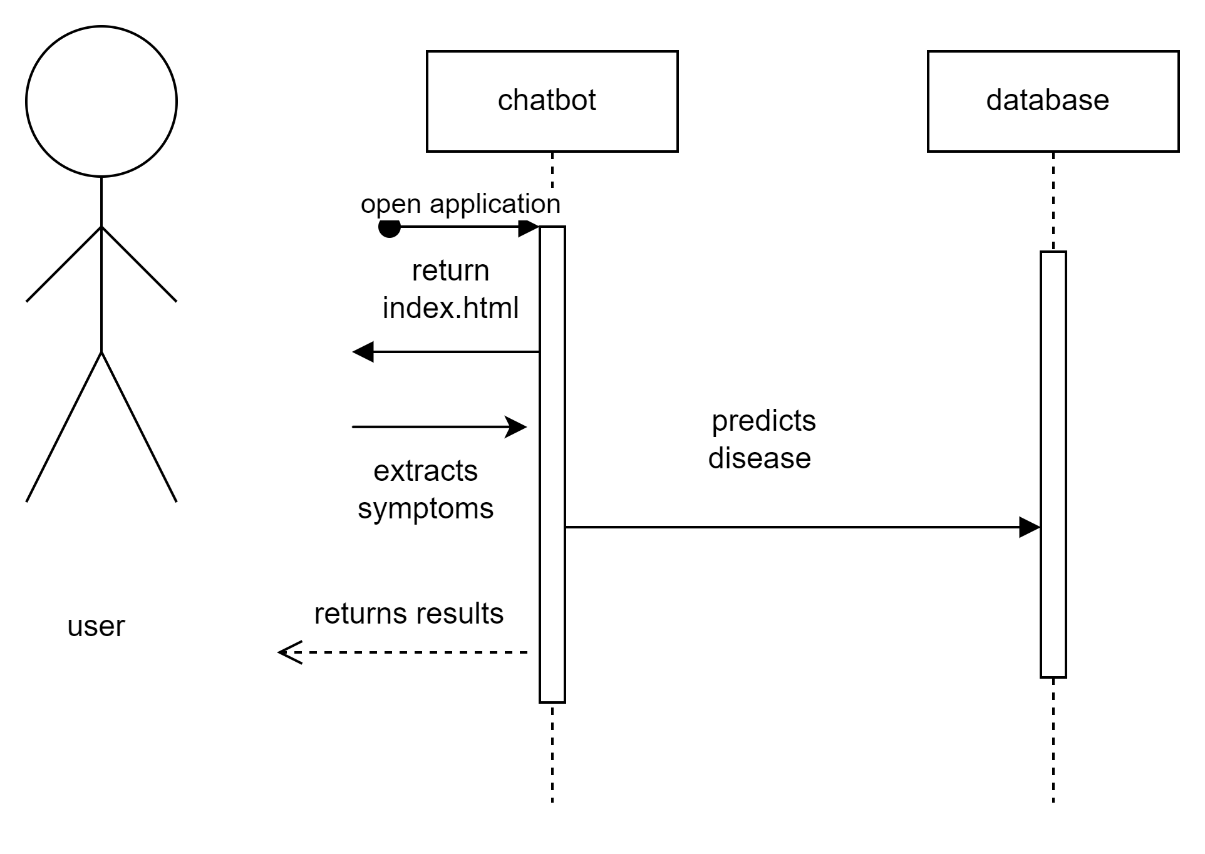

**Output :**

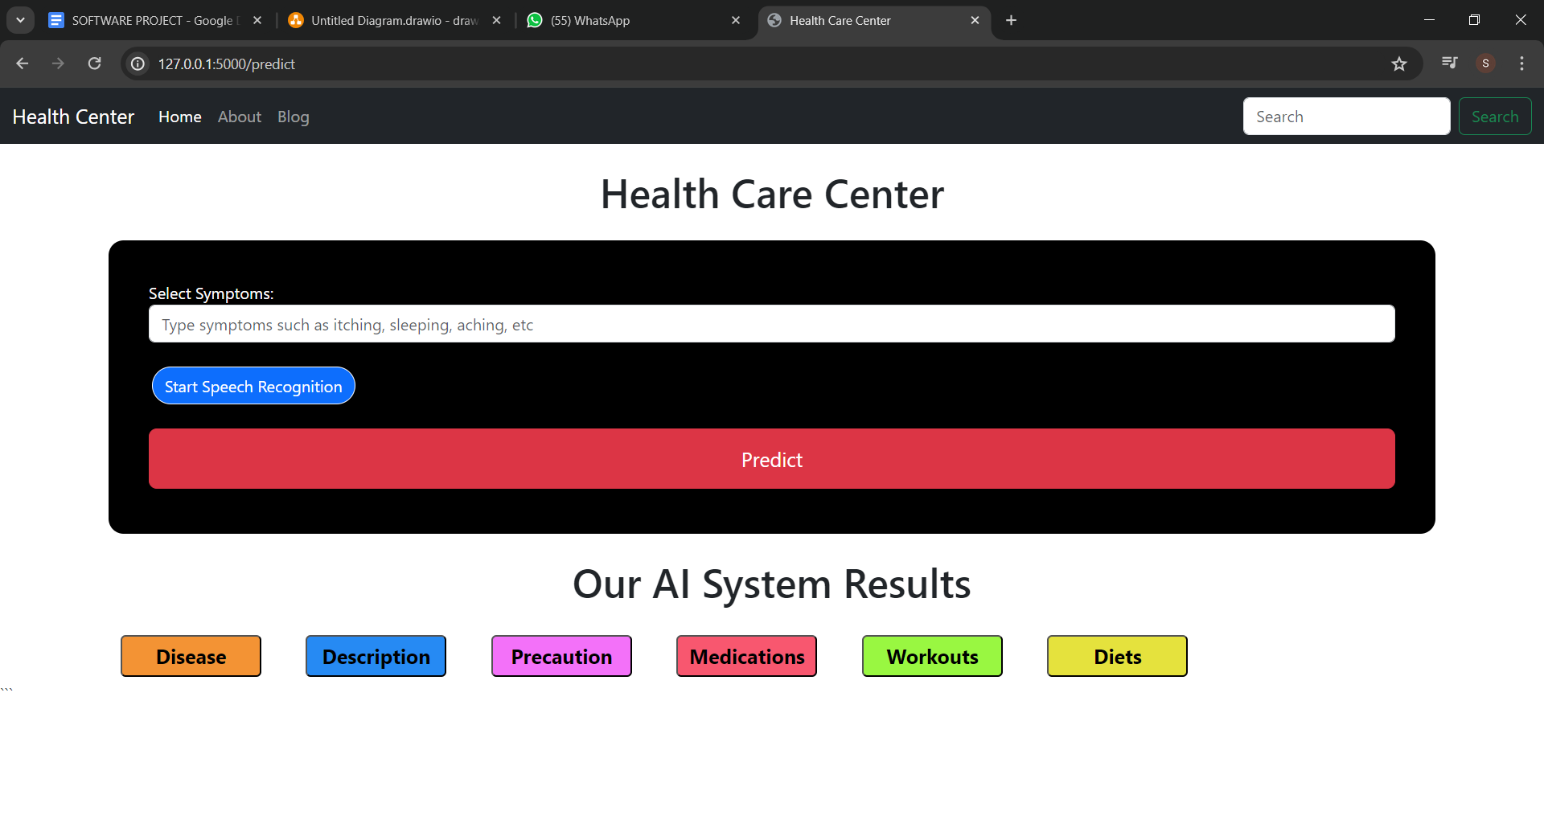

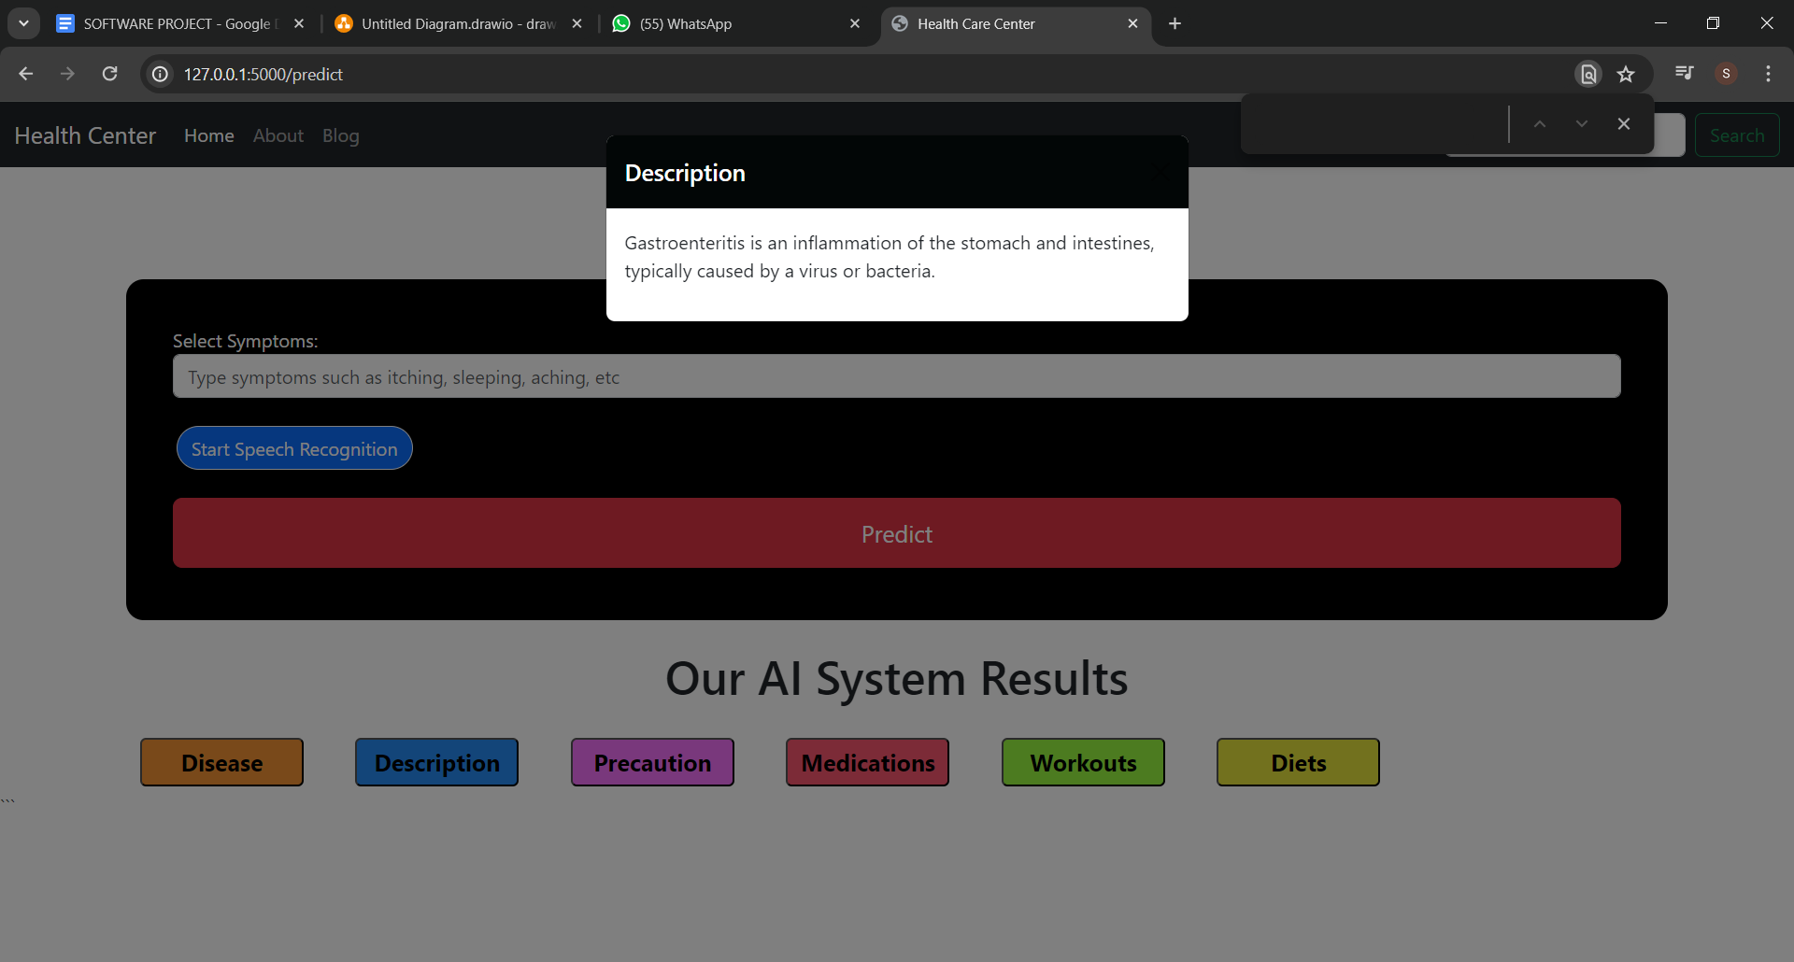

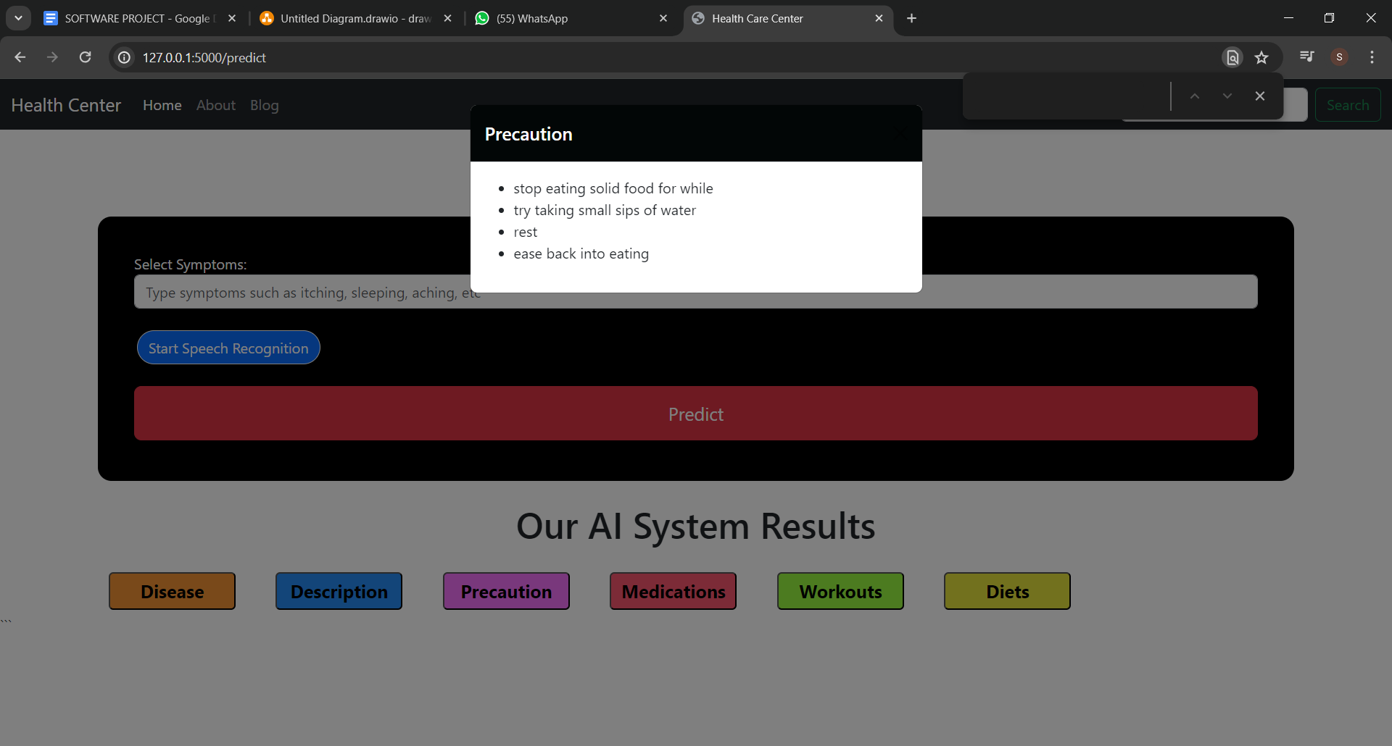

**Limitations future scope and conclusion**

**Limitations :**

**Limited Dataset:** The medical chatbot system relies on a predefined dataset of symptoms, diseases, precautions, medications, diets, and workouts. This dataset may not cover all possible medical conditions or scenarios, limiting the chatbot's ability to provide accurate information and recommendations in certain cases.

**Lack of Real-time Updates:** The current implementation does not include a mechanism for updating the knowledge base with the latest medical information or research findings. As medical knowledge evolves rapidly, the chatbot may become outdated over time, potentially providing inaccurate or obsolete information.

**Limited Natural Language Processing:** While the chatbot can interpret user input in the form of symptoms, it may struggle with more complex or ambiguous natural language queries, limiting its ability to understand and respond appropriately to users' questions or concerns.

**Future scope :**

**Expanding the Knowledge Base:** Continuously updating and expanding the knowledge base with the latest medical information, research findings, and treatment guidelines can significantly improve the chatbot's accuracy and relevance.

**Improving Natural Language Processing:** Incorporating advanced natural language processing techniques, such as deep learning models or contextual language understanding, can enhance the chatbot's ability to comprehend and respond to more complex and nuanced user queries.

**Conclusion:**

The medical chatbot Flask application provides a convenient and accessible way for users to obtain information about diseases, precautions, medications, diets, and workouts based on their reported symptoms. However, it is essential to acknowledge the limitations of the current implementation, such as the reliance on a predefined dataset, lack of real-time updates, limited natural language processing capabilities, and the inability to provide personalized treatment plans or perform actual medical diagnoses.

To address these limitations and improve the chatbot's effectiveness, future efforts should focus on expanding and continuously updating the knowledge base, integrating with electronic health records and diagnostic tools, enhancing natural language processing capabilities, and incorporating telemedicine features. Additionally, improving the user experience through a more intuitive interface and multimedia content could increase user engagement and satisfaction.

It is important to note that while the medical chatbot can serve as a valuable information resource and provide general recommendations, it should not be considered a substitute for professional medical advice or treatment. Users should always consult with qualified healthcare professionals for accurate diagnoses and personalized treatment plans.

Overall, the medical chatbot Flask application demonstrates the potential of leveraging technology to provide accessible and convenient medical information to users. With continuous improvements and integration with advanced medical systems, such chatbots can become powerful tools to support healthcare delivery and empower individuals to better understand and manage their health.

**References :**

**Here are some potential references that could be relevant for the medical chatbot Flask application:**

1. Developers.google.com. (2023). Flask | Python Web App Framework. [online] Available at: https://developers.google.com/tech-tools/resources/frameworks/python/flask [Accessed 13 May 2024].

2. Pandas.pydata.org. (2023). pandas - Python Data Analysis Library. [online] Available at: https://pandas.pydata.org/ [Accessed 13 May 2024].

3. Numpy.org. (2023). NumPy. [online] Available at: https://numpy.org/ [Accessed 13 May 2024].

4. Scikit-learn.org. (2023). scikit-learn: Machine Learning in Python. [online] Available at: https://scikit-learn.org/stable/ [Accessed 13 May 2024].

5. Flask.palletsprojects.com. (2023). Flask Documentation (2.3.x). [online] Available at: https://flask.palletsprojects.com/en/2.3.x/ [Accessed 13 May 2024].

6. Jiang, F., Jiang, Y., Zhi, H., Dong, Y., Li, H., Ma, S., ... & Wang, Y. (2017). Artificial intelligence in healthcare: past, present and future. Stroke and vascular neurology, 2(4), 230-243.

7. Wahl, B., Cossy-Gantzer, A., Germann, J., & Schwalbe, N. R. (2018). Artificial intelligence (AI) and global health: how can AI contribute to health in resource-poor settings?. BMJ global health, 3(4), e000798.

8. Miner, A. S., Milstein, A., Schueller, S., Hegde, R., Mangurian, C., & Linos, E. (2016). Smartphone-based conversational agents and responses to questions about mental health, interpersonal violence, and physical health. JAMA internal medicine, 176(5), 619-625.

9. Mordor Intelligence. (2023). Medical Chatbot Market - Growth, Trends, COVID-19 Impact, and Forecasts (2023 - 2028). [online] Available at: https://www.mordorintelligence.com/industry-reports/medical-chatbot-market [Accessed 13 May 2024].

10. World Health Organization. (2023). Digital health. [online] Available at: https://www.who.int/health-topics/digital-health [Accessed 13 May 2024].

These references cover topics such as the Flask web framework, Python libraries used in the application (Pandas, NumPy, scikit-learn), artificial intelligence in healthcare, the potential of chatbots and conversational agents in healthcare, market analysis for medical chatbots, and digital health initiatives by the World Health Organization.